- Задание
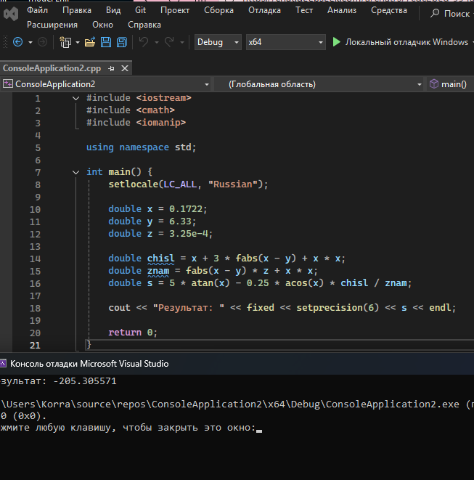
#include <iostream>
#include <cmath>
#include <iomanip>

using namespace std;

int main() {
setlocale(LC_ALL, "Russian");

double x = 0.1722;
double y = 6.33;
double z = 3.25e-4;

double chisl = x + 3 * fabs(x - y) + x * x;
double znam = fabs(x - y) * z + x * x;
double s = 5 * atan(x) - 0.25 * acos(x) * chisl / znam;

cout << "Результат: " << fixed << setprecision(6) << s << endl;

return 0;
}

- Задание

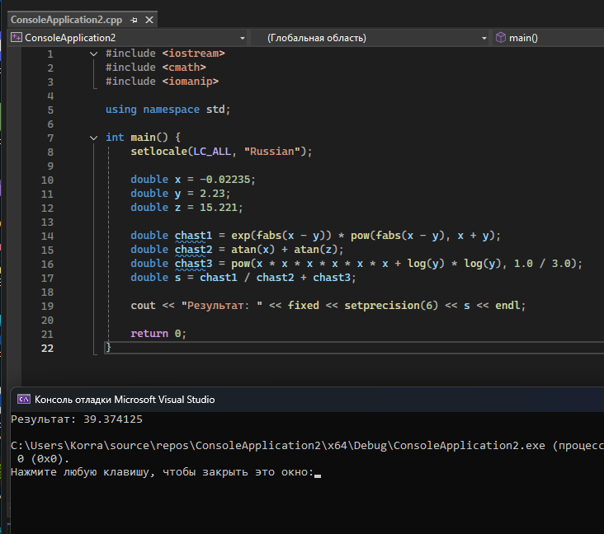

#include <iostream>
#include <cmath>
#include <iomanip>

using namespace std;

int main() {
setlocale(LC_ALL, "Russian");

double x = -0.02235;
double y = 2.23;
double z = 15.221;

double chast1 = exp(fabs(x - y)) * pow(fabs(x - y), x + y);
double chast2 = atan(x) + atan(z);
double chast3 = pow(x * x * x * x * x * x + log(y) * log(y), 1.0 / 3.0);
double s = chast1 / chast2 + chast3;

cout << "Результат: " << fixed << setprecision(6) << s << endl;

return 0;
}

